Linear Regression

Simple linear regression is a statistical method that allows us to summarize and study relationships between two continuous (quantitative) variables:
- One variable, denoted x, is regarded as the predictor, explanatory, or independent variable.
- The other variable, denoted y, is regarded as the response, outcome, or dependent variable.
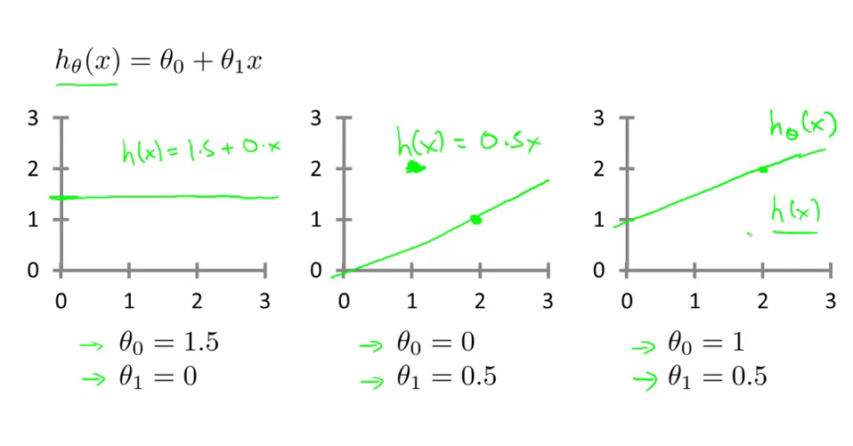

Cost Function
We can measure the accuracy of our hypothesis function by using a cost function. This takes an average difference (actually a fancier version of an average) of all the results of the hypothesis with inputs from x's and the actual output y's.
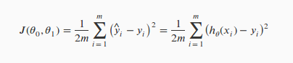
To break it apart, it is where is the mean of the squares of , or the difference between the predicted value and the actual value.
This function is otherwise called the "Squared error function", or "Mean squared error". The mean is halved as a convenience for the computation of the gradient descent, as the derivative term of the square function will cancel out the term. The following image summarizes what the cost function does:
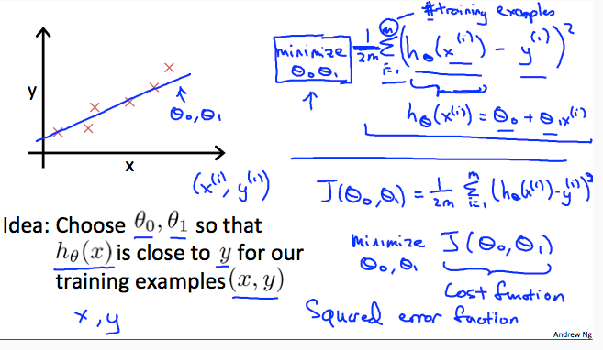

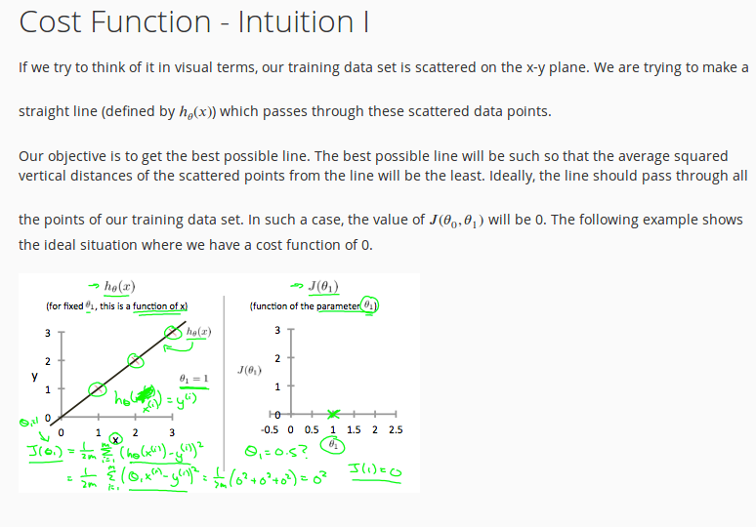
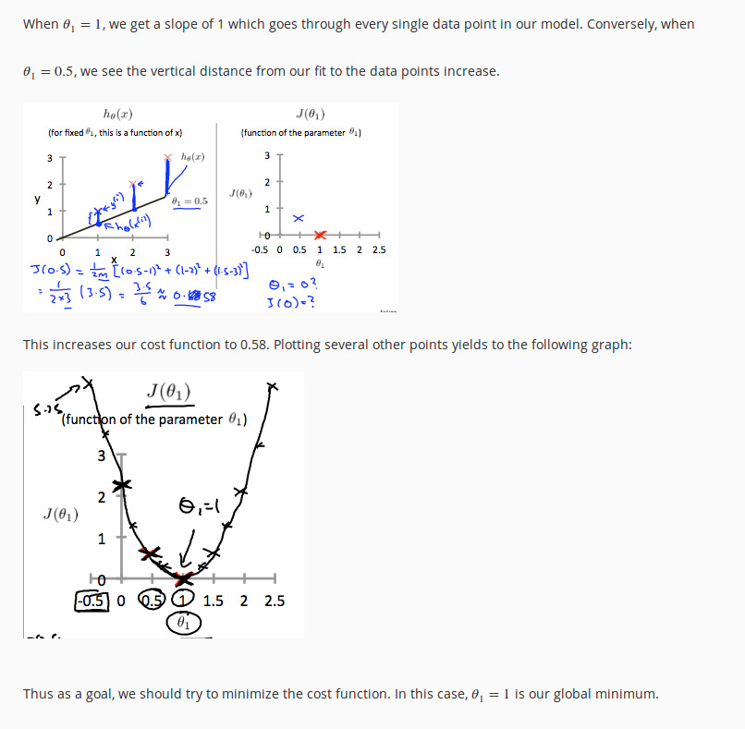
‘.

Y | 10 | 15 | 5 | 4 | 3 | 13
X | 7 | 10 | 4 | 3 | 2 | 9

N = 6

Y | X | x*y | x^2
10 | 7 | 70 | 49
15 | 10 | 150 | 100
5 | 4 | 20 | 16
4 | 3 | 12 | 9
3 | 2 | 6 | 4
13 | 9 | 117 | 81
∑y | ∑x | ∑x*y | ∑x^2
50 | 35 | 375 | 259

